

Faculty of Computing and Information Technology

KL MAIN CAMPUS

2021 / 2022 SEMESTER 1

**BAMS3043 Mathematical and Statistical Software**

Bachelor of Science (Honours) in Management Mathematics with Computing

Assignment 1 (20%)

Title: CASE 3--Monthly Personal Budget

Lecturer / Tutor: Dr Tan Yan Bin

Name: Hong Wei Hao

Student ID: 19WMR02419

Programme / Tutorial Class: RMM3G1

Date of Submission: 5 September 2021, 5pm

1. **Process**

1st step:

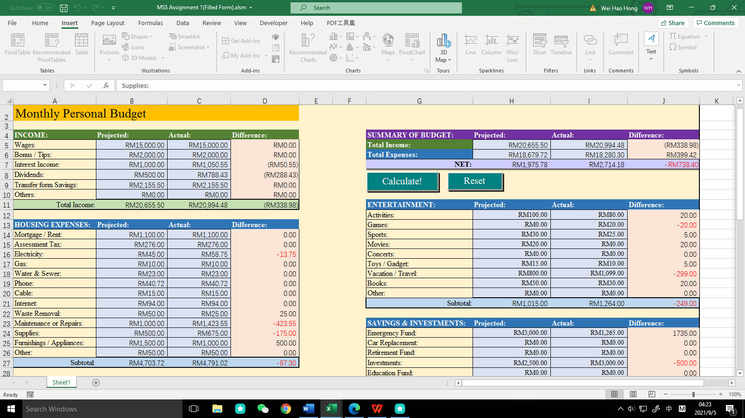

First, there will be 1 Income category and 10 Expenses categories in this Monthly Personal Budget Form, and each of the category will distinguish to different types inside to make this form more clearly. From the table above, we can see that in income category and housing expenses category , both of it have projected value, actual value, and difference value column. In income category, if its projected budget smallest than actual budget, it means the user will save and gain more profit. On the other hand, it will loss more in expenses category and show red font in difference column if its projected budget smallest than actual budget.

After that, user just need to key in amount in ‘Projected’ and ‘Actual’ column so that the system will calculate the difference amount between projected value and actual value and the subtotal for each category. In income category, the total difference between projected and actual value is RM 338.98 while in housing expenses category its total difference is RM 87.30 in negative value.

2nd step:

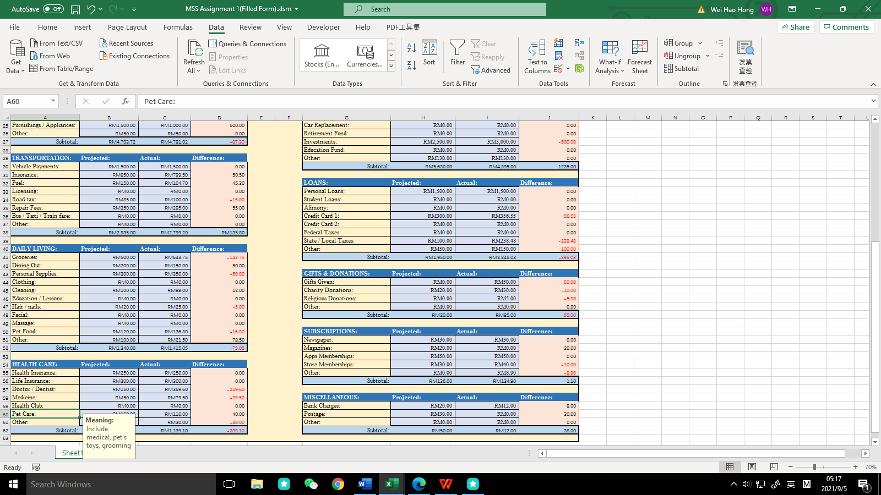

For the transportation category as shown above, we can saw that if the projected cost bigger than actual cost, it will show positive value in the difference column there, and the subtotal will be positive value also if its positive value more than negative value. So, when user finished key in the amount, he can know that for each category he will save more or spend more.

User may also choose a certain type he doesn’t understand and click on it as it will prompt up a message to let him know what this type represents.

3rd step:

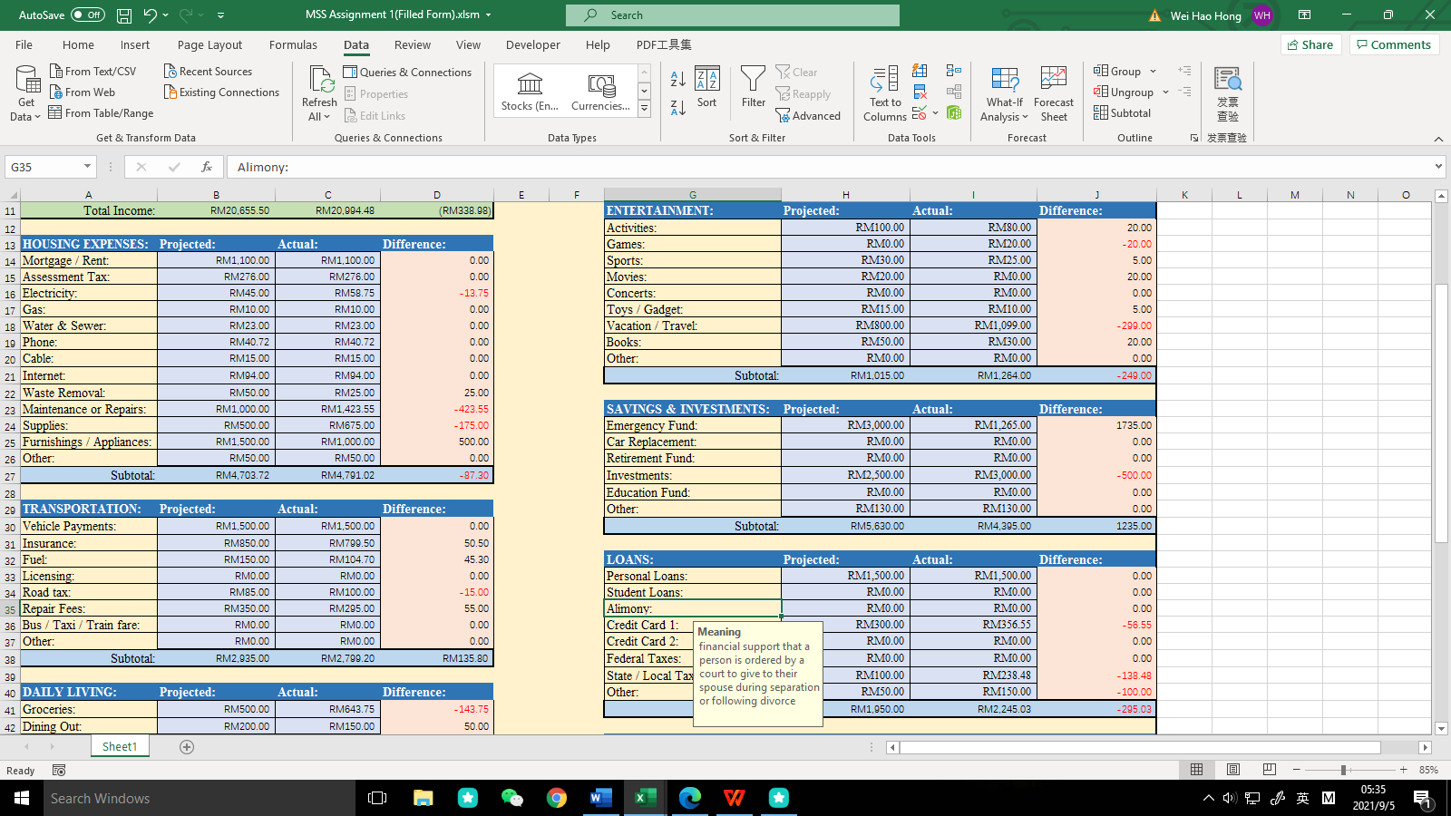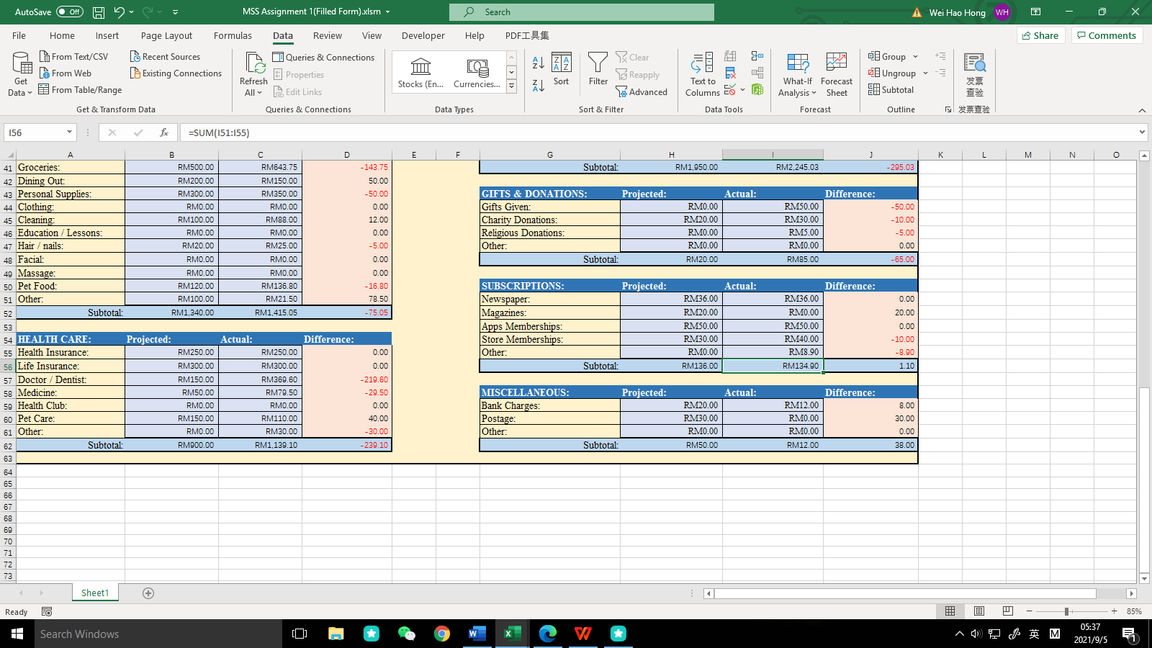

Same as 2nd step just now, if user don’t understand the meaning of that type, he can just click on that type as it will prompt up a message to let him know what this type represents so that he no need to search the meaning and save the time.

All categories will have a “Other” type incase user their expenses are unique and don’t belong to any types inside the categories.

4th step:

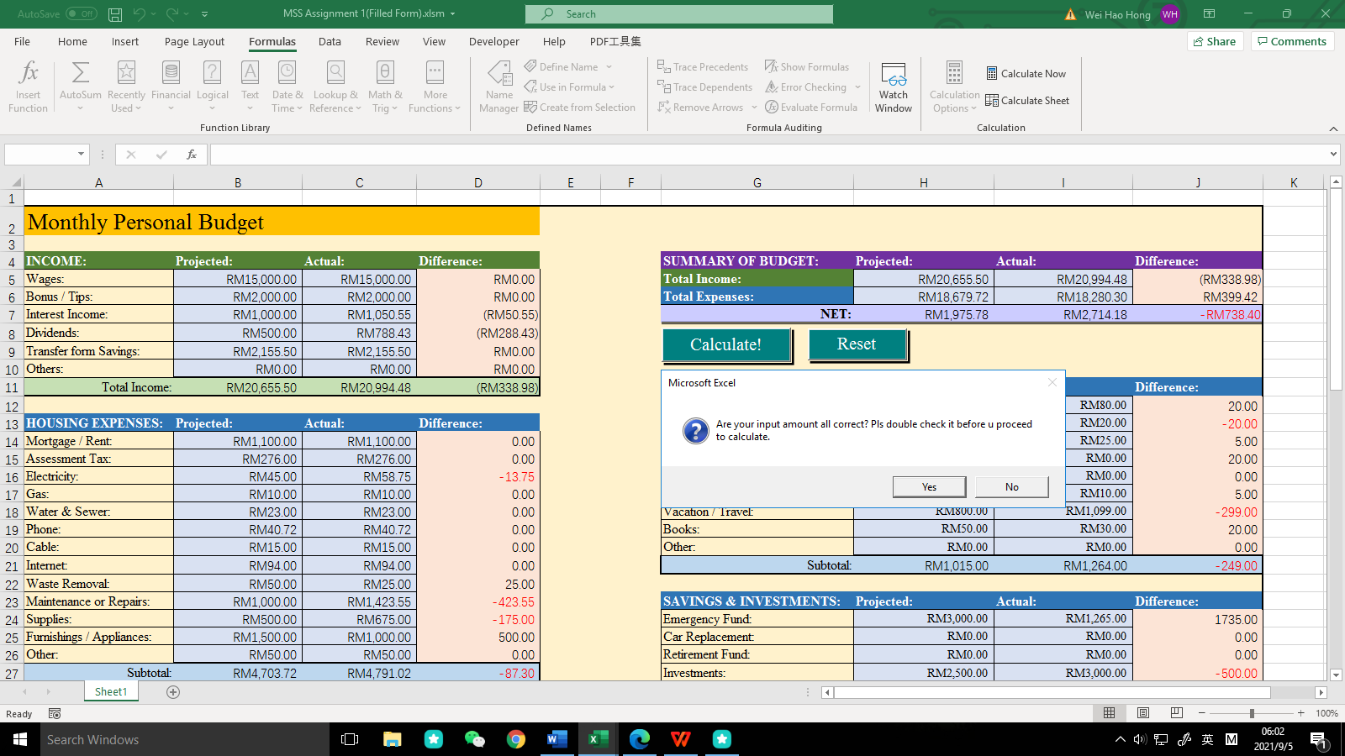

After user key in all the amount of all categories, user can click the “Calculate!” button, and it will prompt up a message to ask user to double check the amount that he keys in, so that the result will be accurate. If user click “No”, it will go back to the form and let user change the amount, else it will show the result as follow:

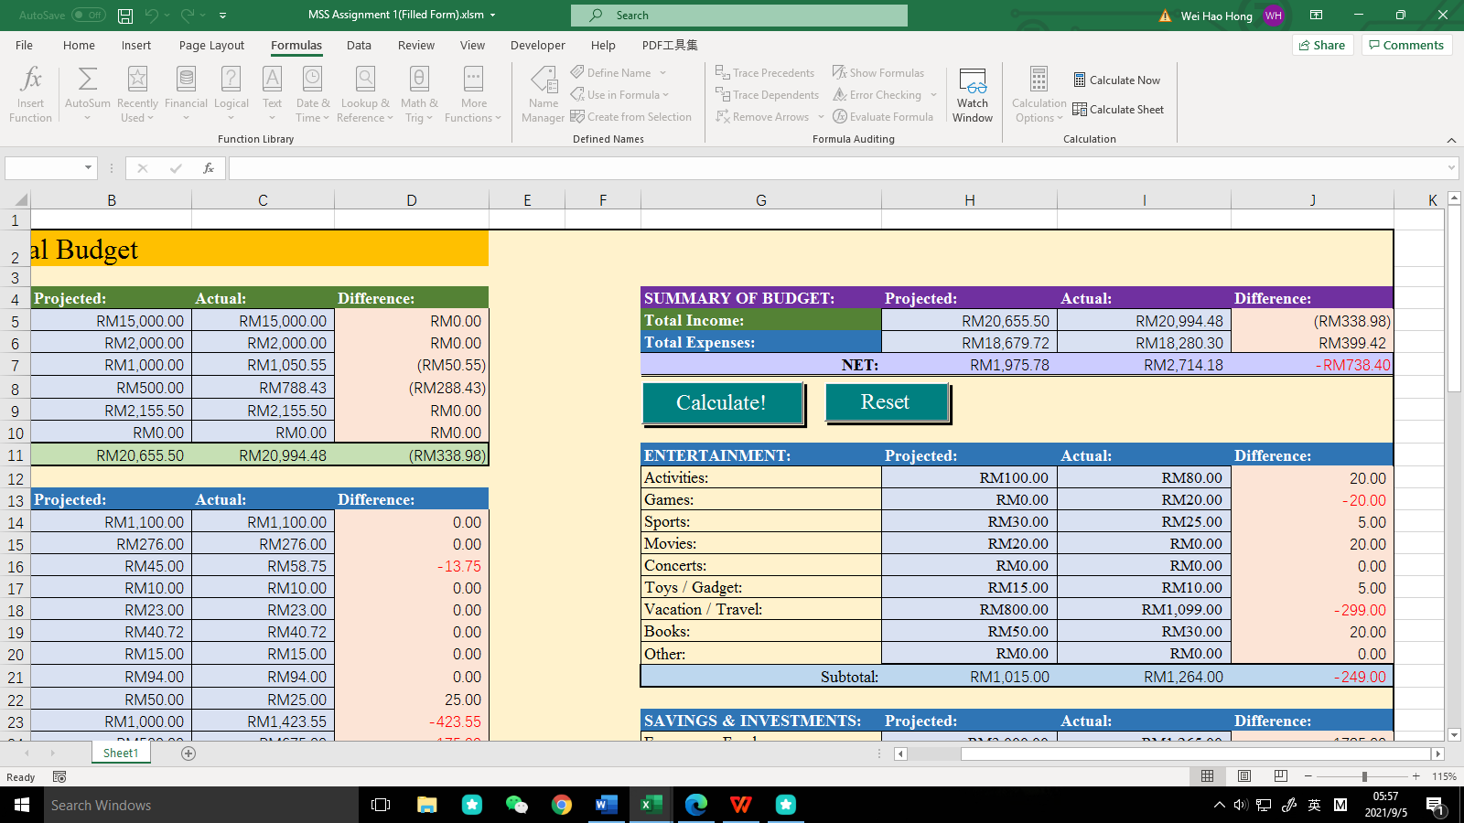

This summary table allow user to know their monthly balance and he will know whether their projected value is accurate. From the table above, we can see that its projected value compared to actual value have a difference of RM 738.40 in negative value. It means user spend less in this month compared to his projected expenses because its actual balance is more than projected balance.

5th step:

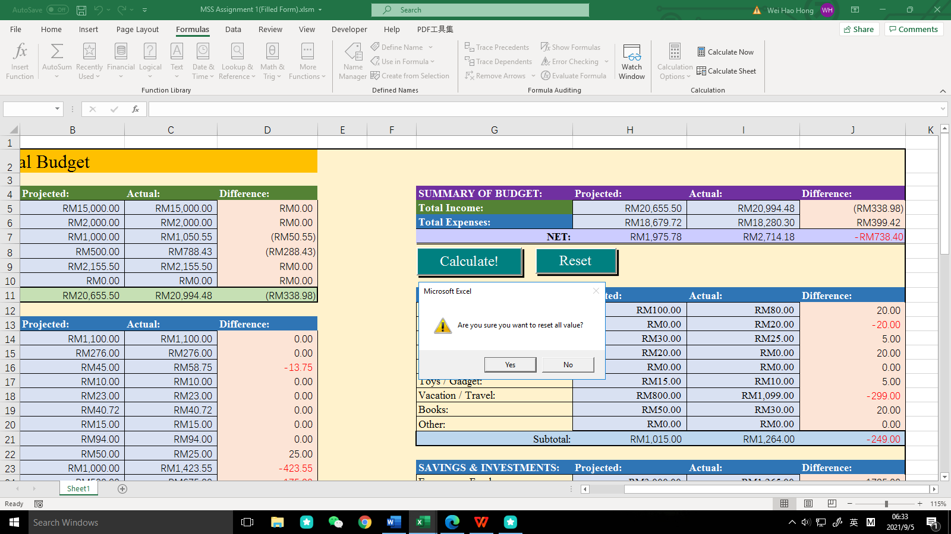

At last, this monthly personal budget can be used multiple times according to the user’s preferences, so if user want to calculate for another monthly budget, then just click the “Reset” button, and it will prompt the user whether to reset all value to ensure he didn’t miss any data. If user click “No”, it will return to the form, otherwise all input values and results will be cleared and become a new monthly personal budget form.

1. **Benefit of Monthly Personal Budget Form**

This form can help many people especially teenagers and college students to improve their financial concept. It is because with this form, they can know how much they can spend in this one month and their projected cost is to help them save more money. If their actual cost is less than projected cost, they will be happier also because they can use these money to do investment or use as education lesson also. In addition, this form is simple and user-friendly. Users only need to key in the amount of their expenses and income for the current month, and then click a “Calculate!” button to calculate their projected balance and actual balance at the end of month. Other than that, this form can help user to know which category they should spend less, and whether their income can cover the expenses for the current month, so as not to make ends meet.

After users are familiar with how to use this form, it may be helpful for them to work at big company in future, because the company will calculate a lot of bookkeeping and they can more efficiency in this part.

1. **Personal Thoughts**

After I have finished this assignment, I learned a lot of Microsoft excel function that didn’t see before such as coding inside the Microsoft excel, developer function and other function. I also learned that financial management is a difficult task as it has many expenses u need to consider it. Other than that, I will use Microsoft excel in future also as it is very useful, and this monthly personal budget form I will keep it for further use also. From this form, I known that we must earn more money as there are too many expenses in our daily life. If we don’t work hard now, our personal budget form will make ends meet every month.